ASSIGNMENT 2 - SDT
MUHAMMAD AFIQ DANIAL BIN ROZAIDIE A23CS0117
MYSQL - SQL
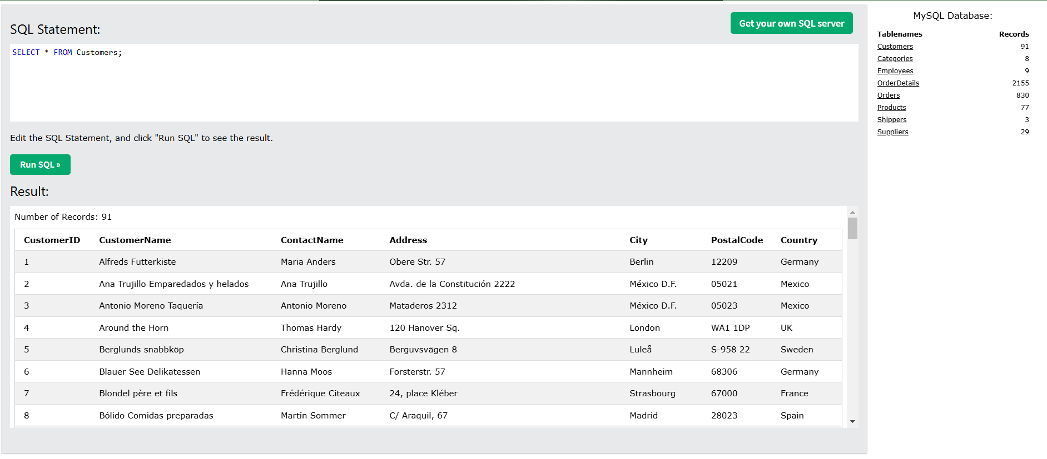
SELECT Columns Example
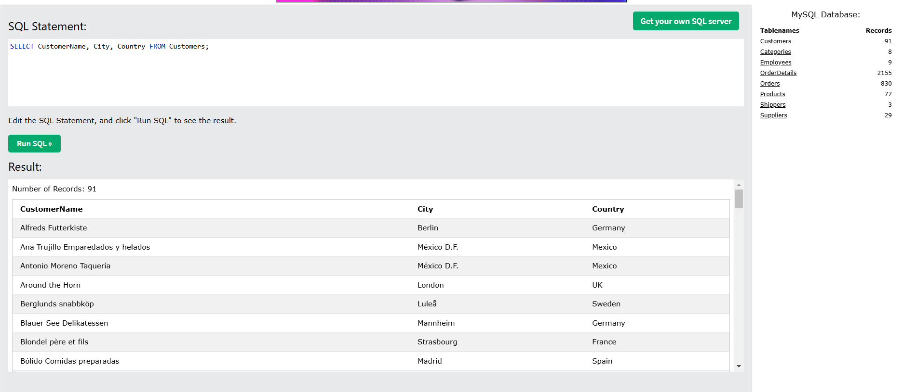

SELECT Example Without DISTINCT
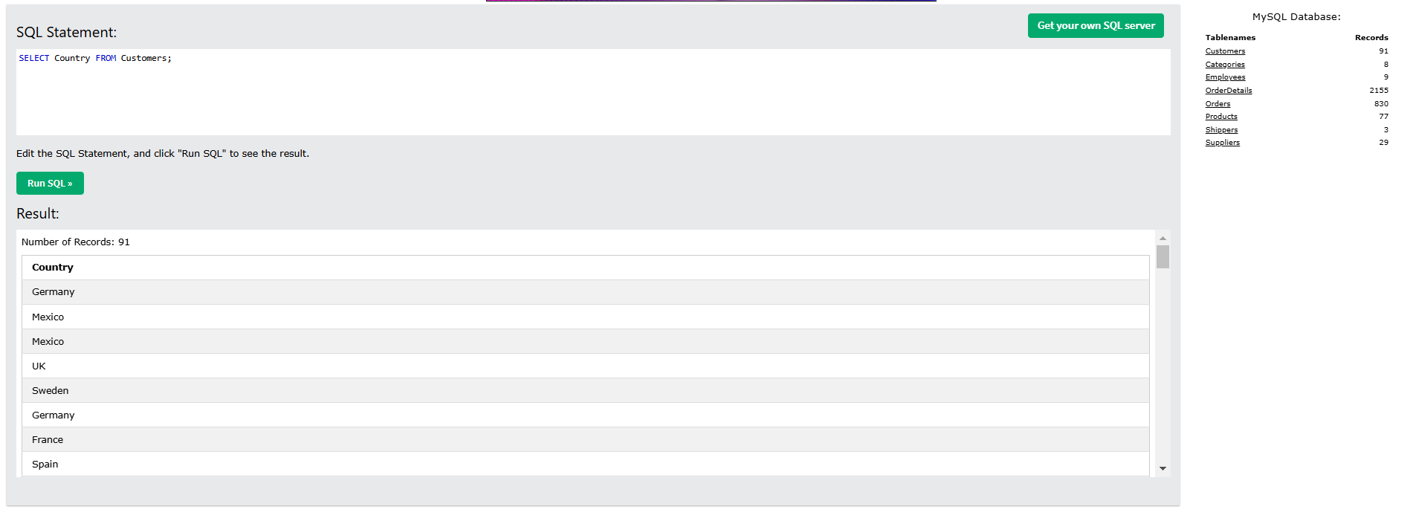
SELECT DISTINCT Examples
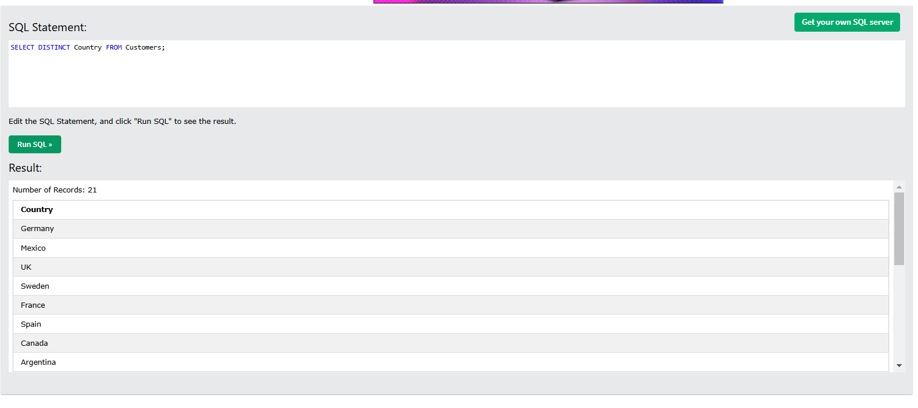

WHERE Clause Example
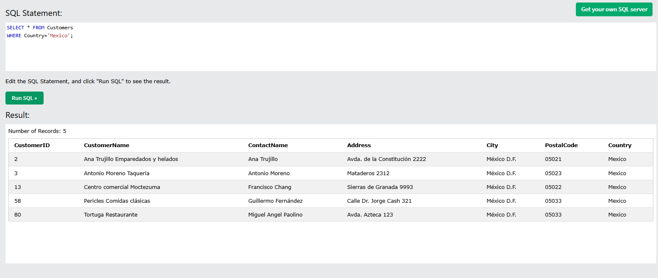
Text Fields vs. Numeric Fields
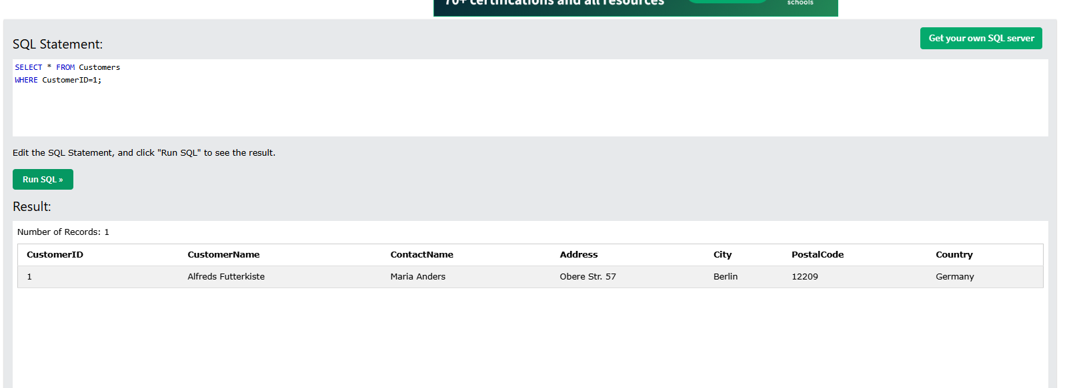
AND Example
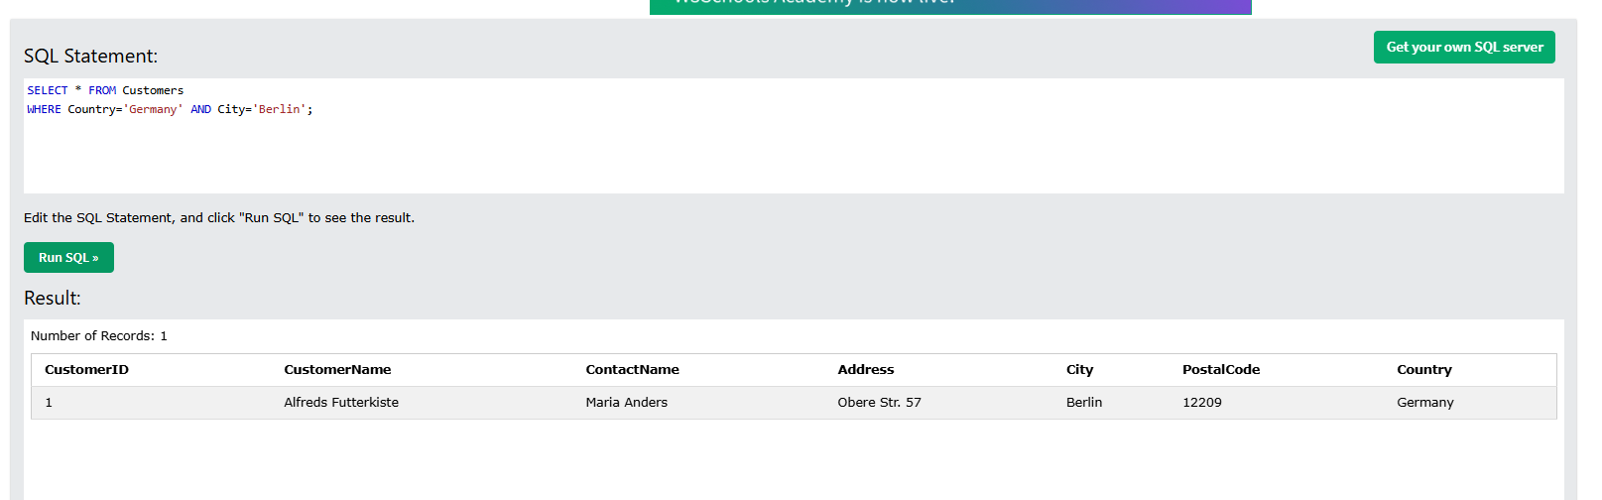

OR Example
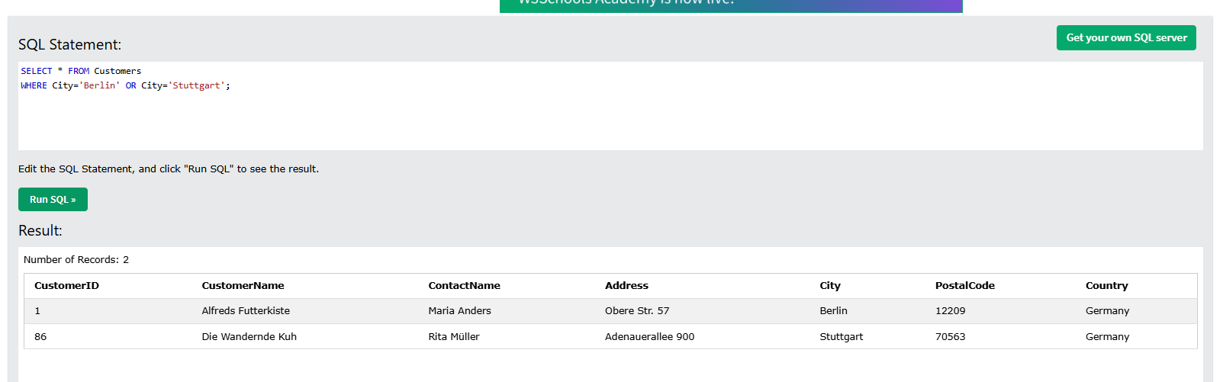
NOT Example
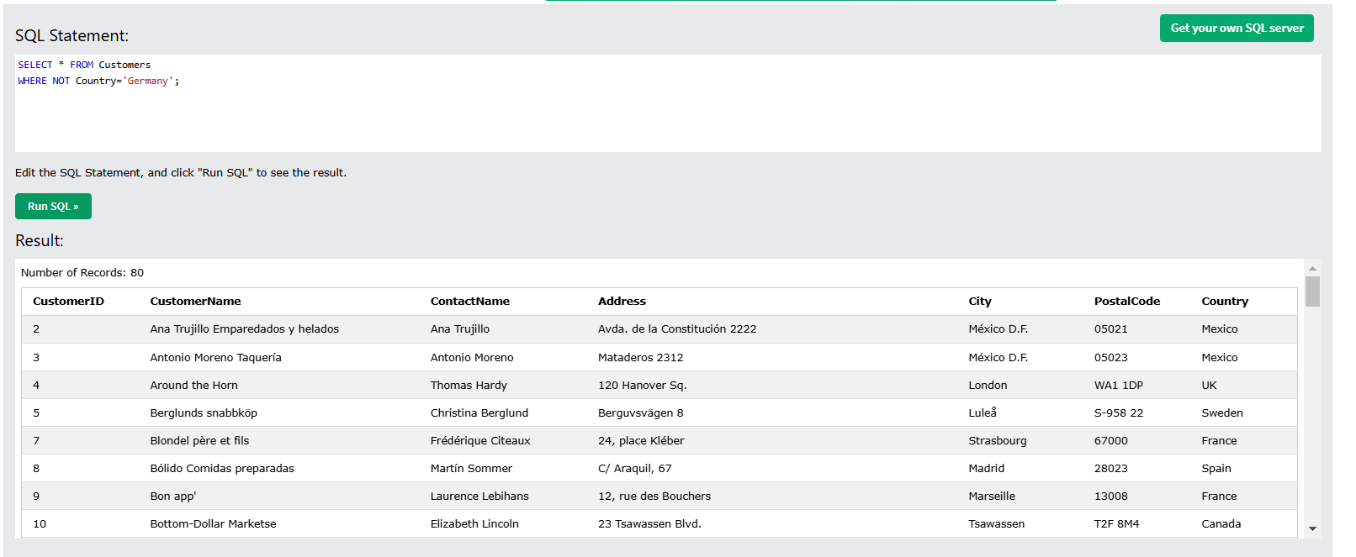
Combining AND, OR and NOT
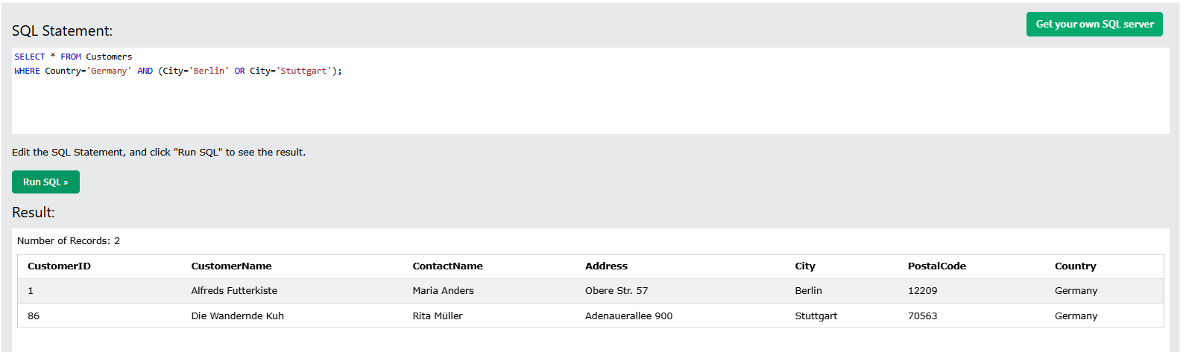

ORDER BY Example
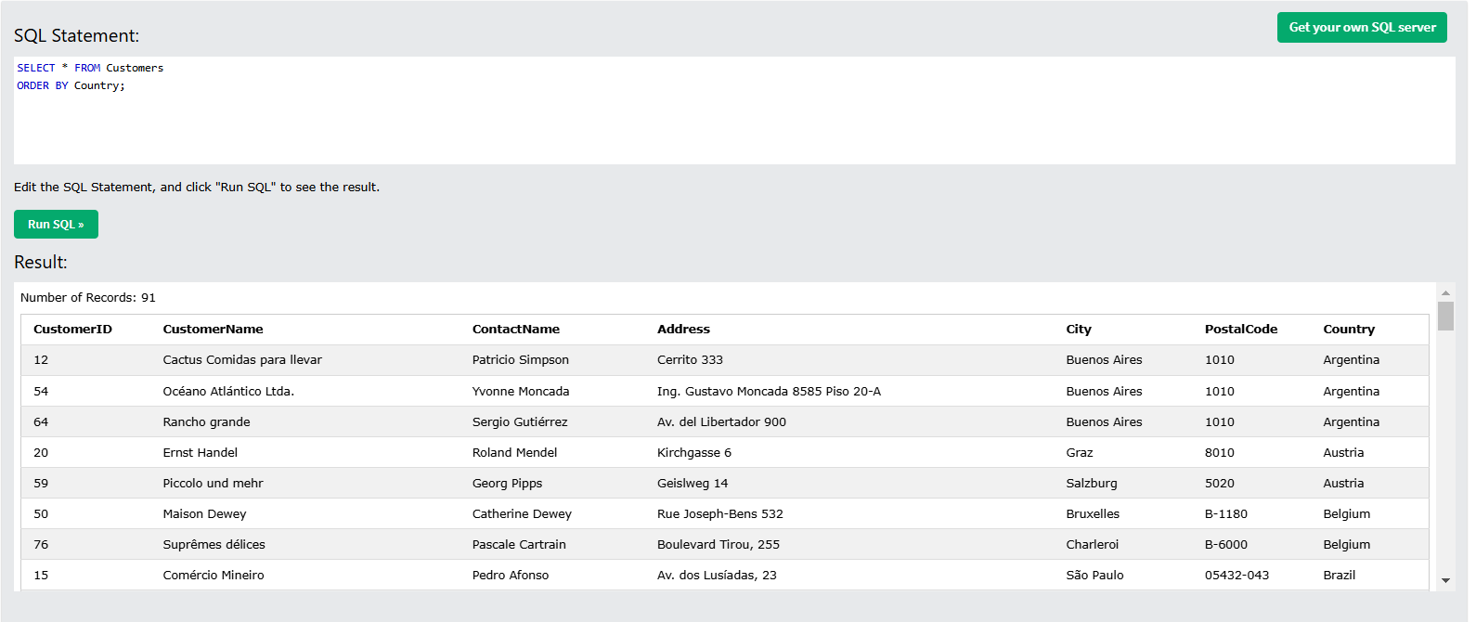
ORDER BY DESC Example
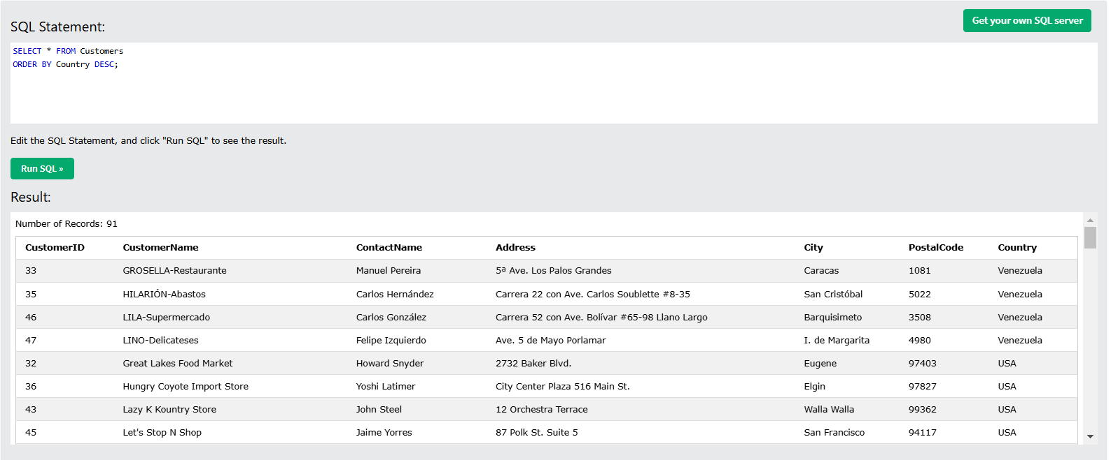
ORDER BY Several Columns Example
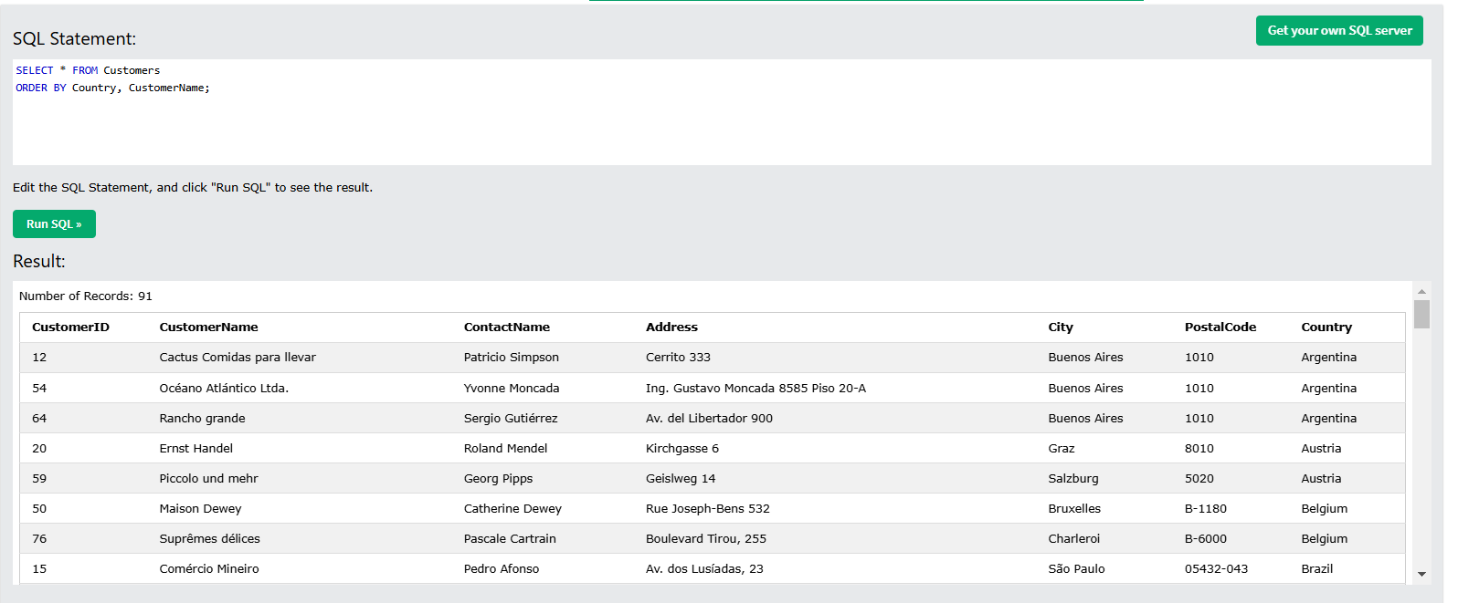

ORDER BY Several Columns Example 2
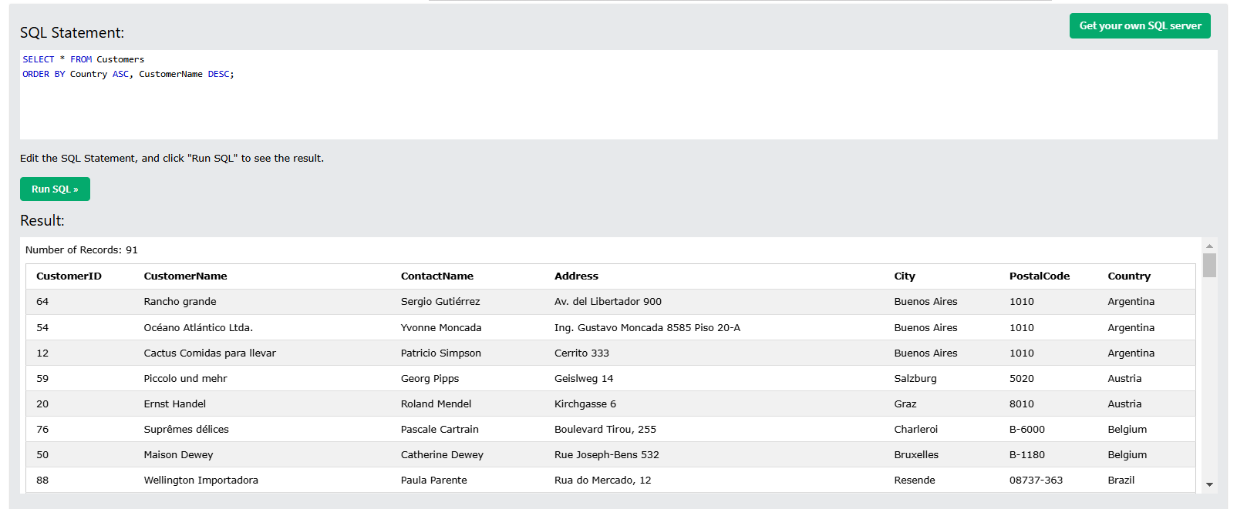
The IS NULL Operator
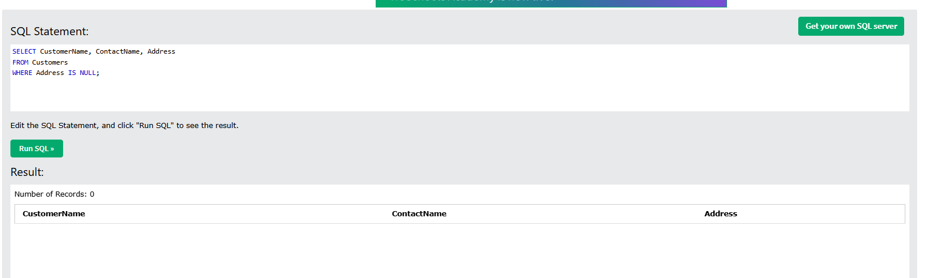
The IS NOT NULL Operator
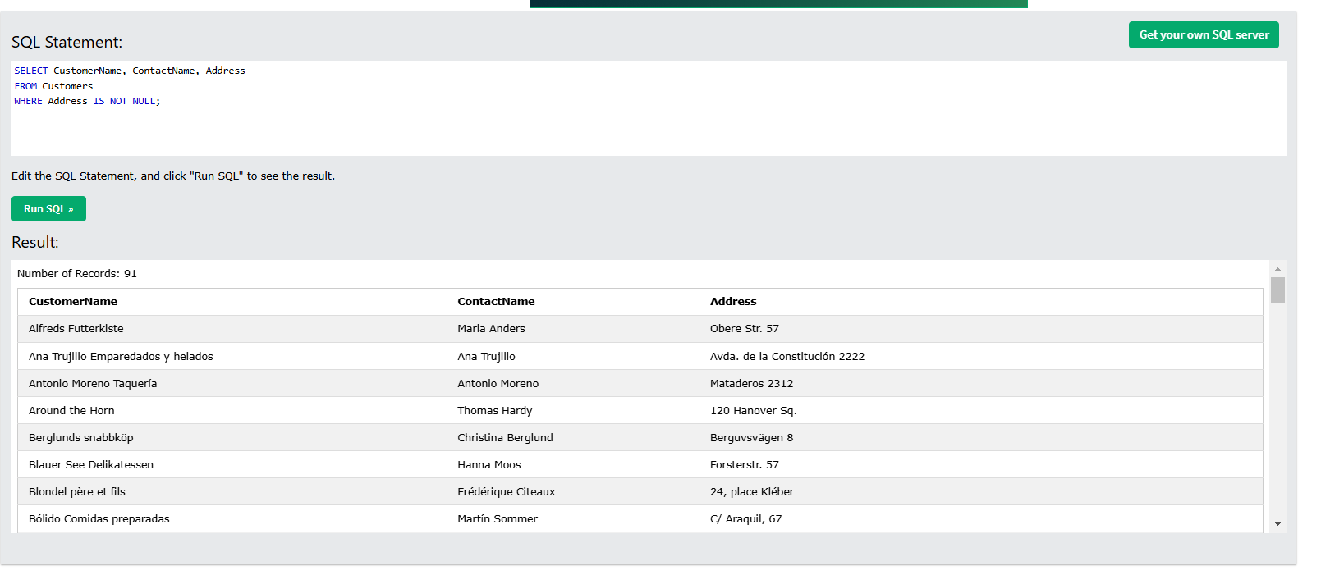

MySQL LIMIT Examples
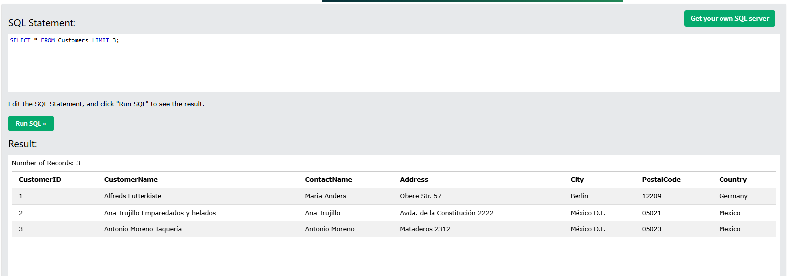
ADD a WHERE CLAUSE
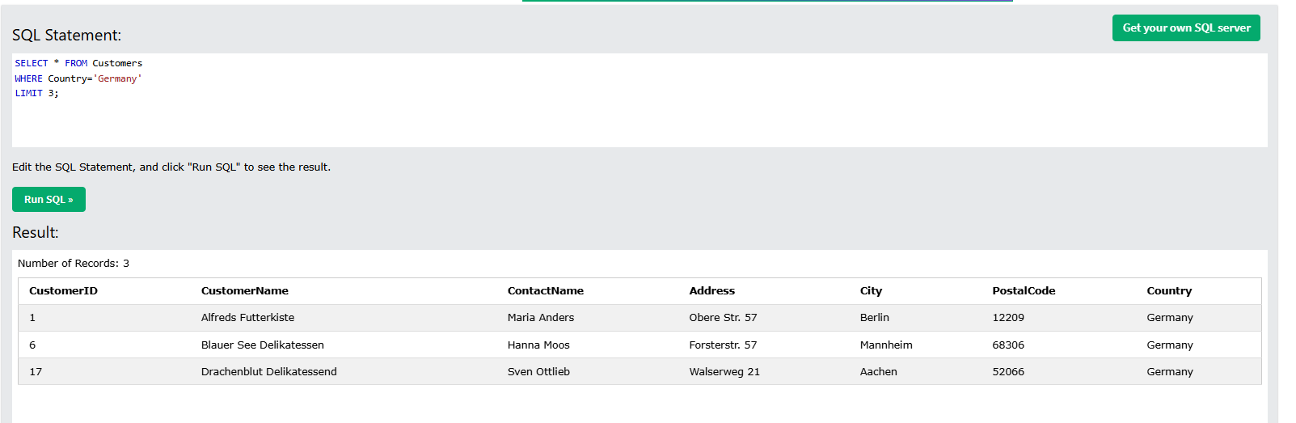
MIN() Example
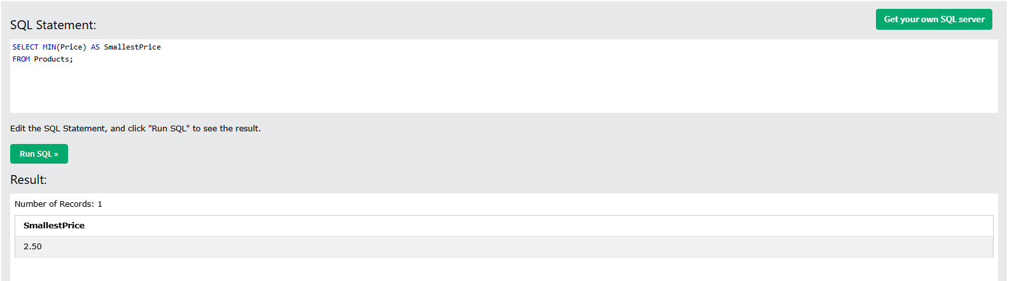

MAX() Example
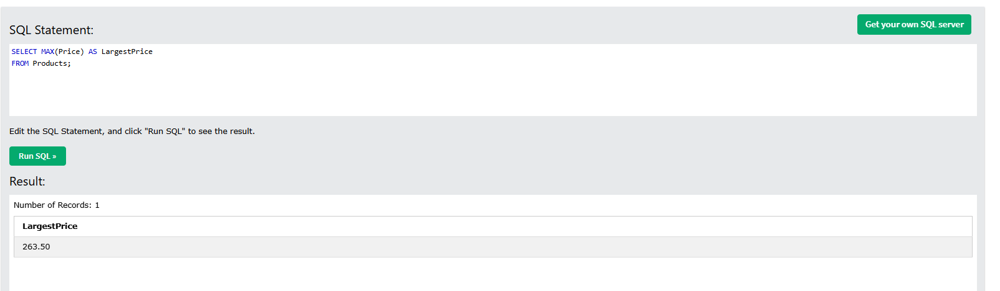
COUNT() Example
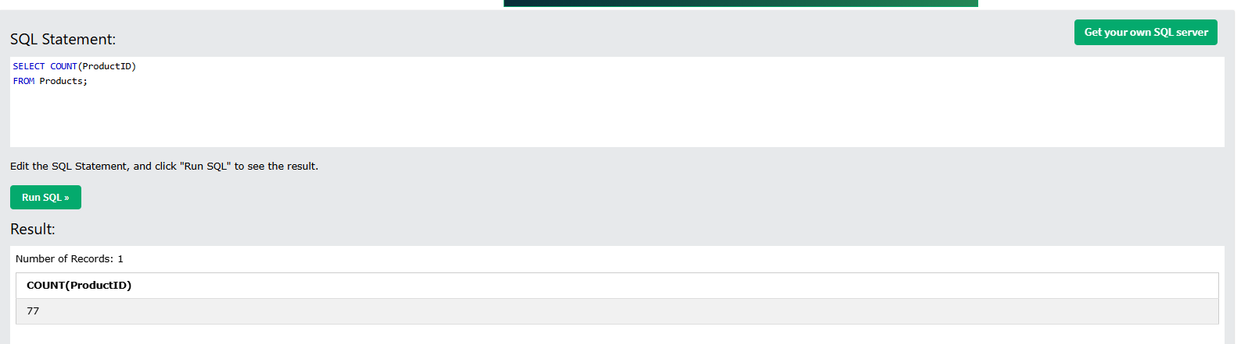
AVG() Example
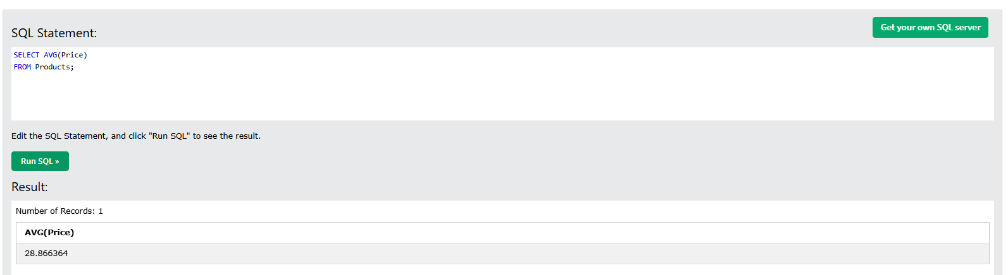

SQL LIKE Examples
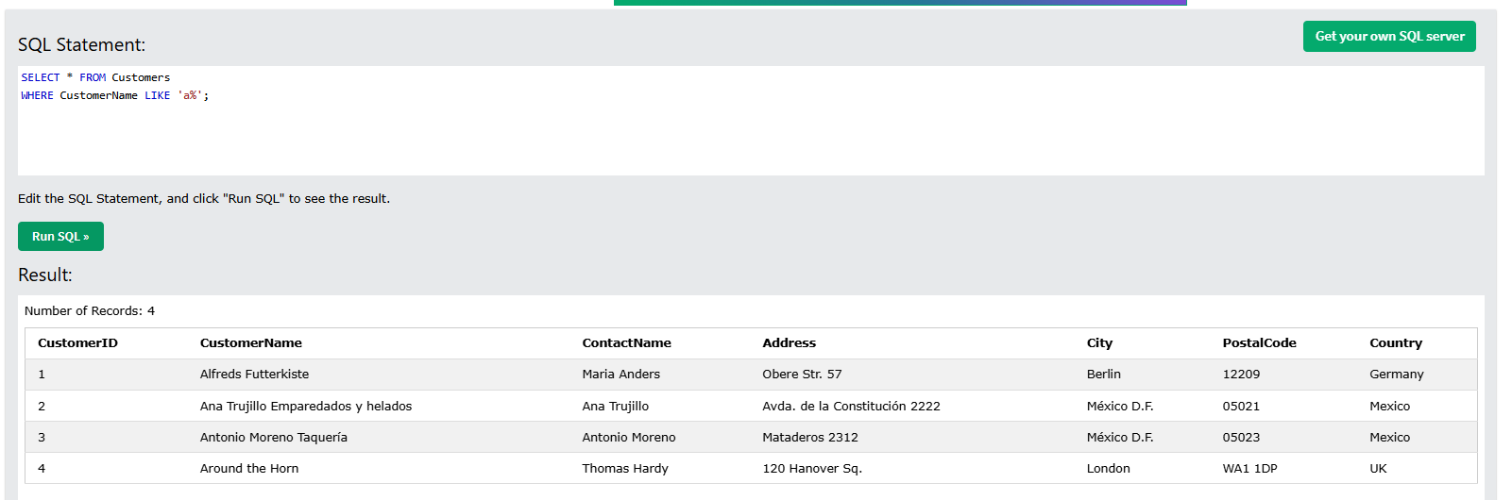
Using the % Wildcard
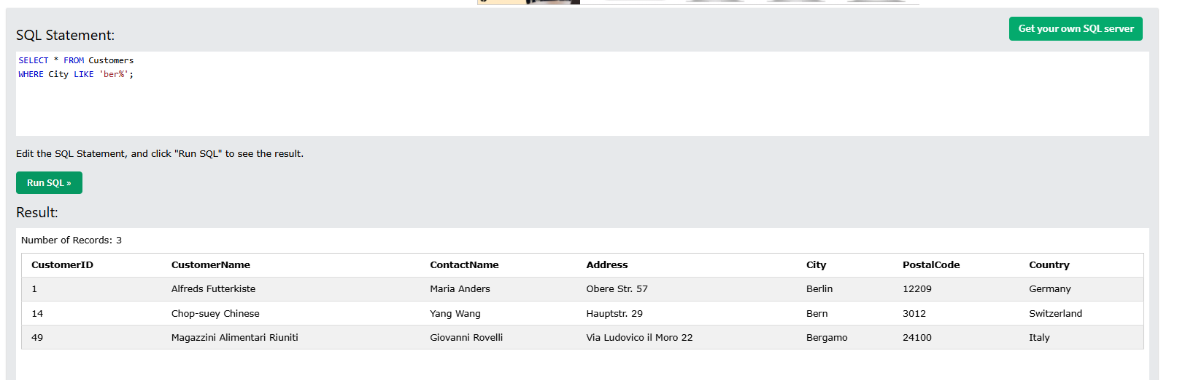
Using the _ Wildcard
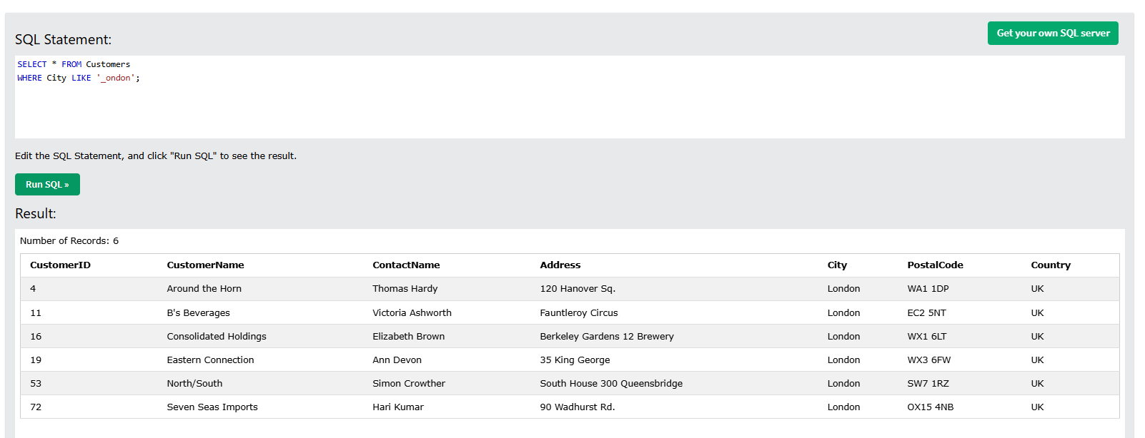

IN Operator Examples
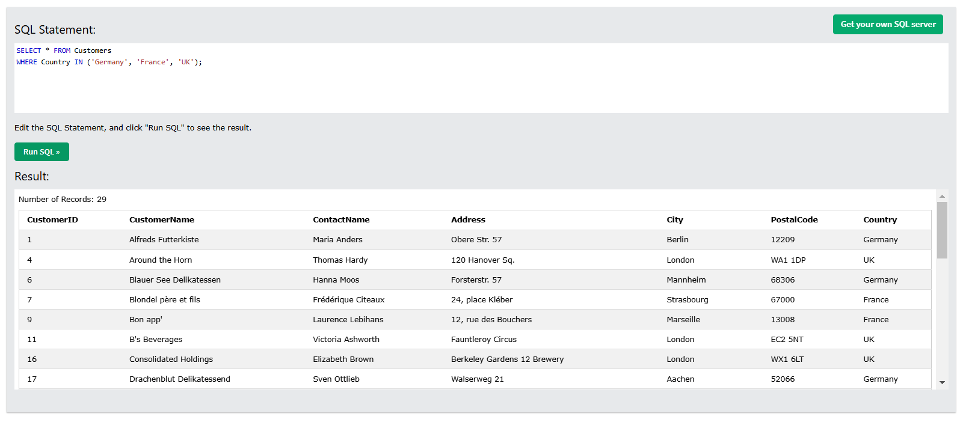
BETWEEN Example
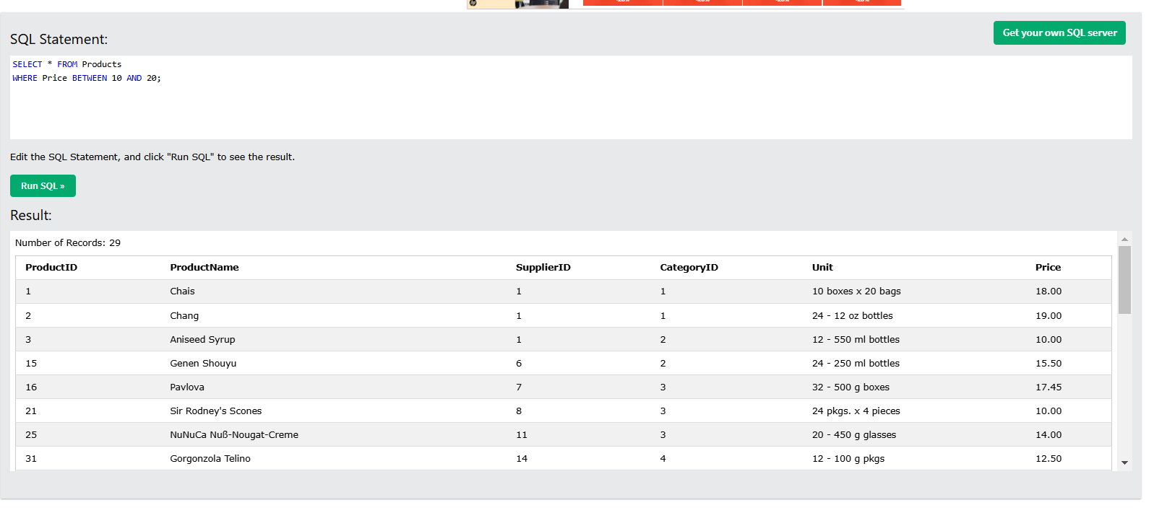
NOT BETWEEN Example
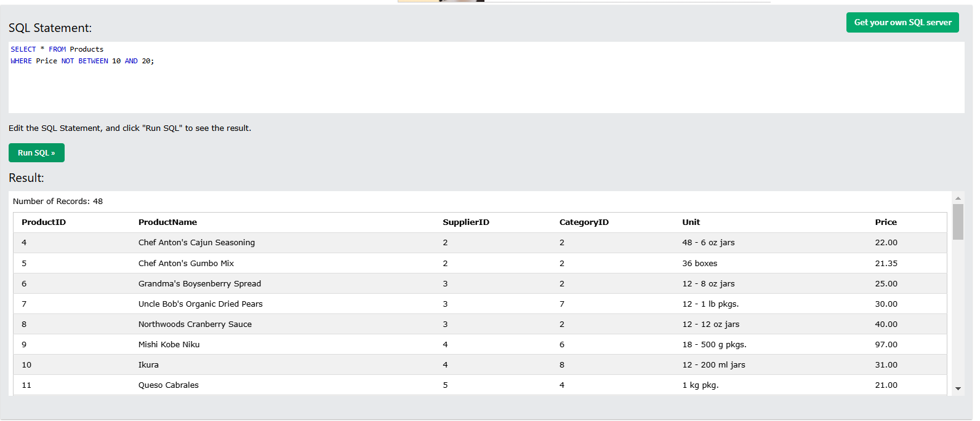
BETWEEN with IN Example
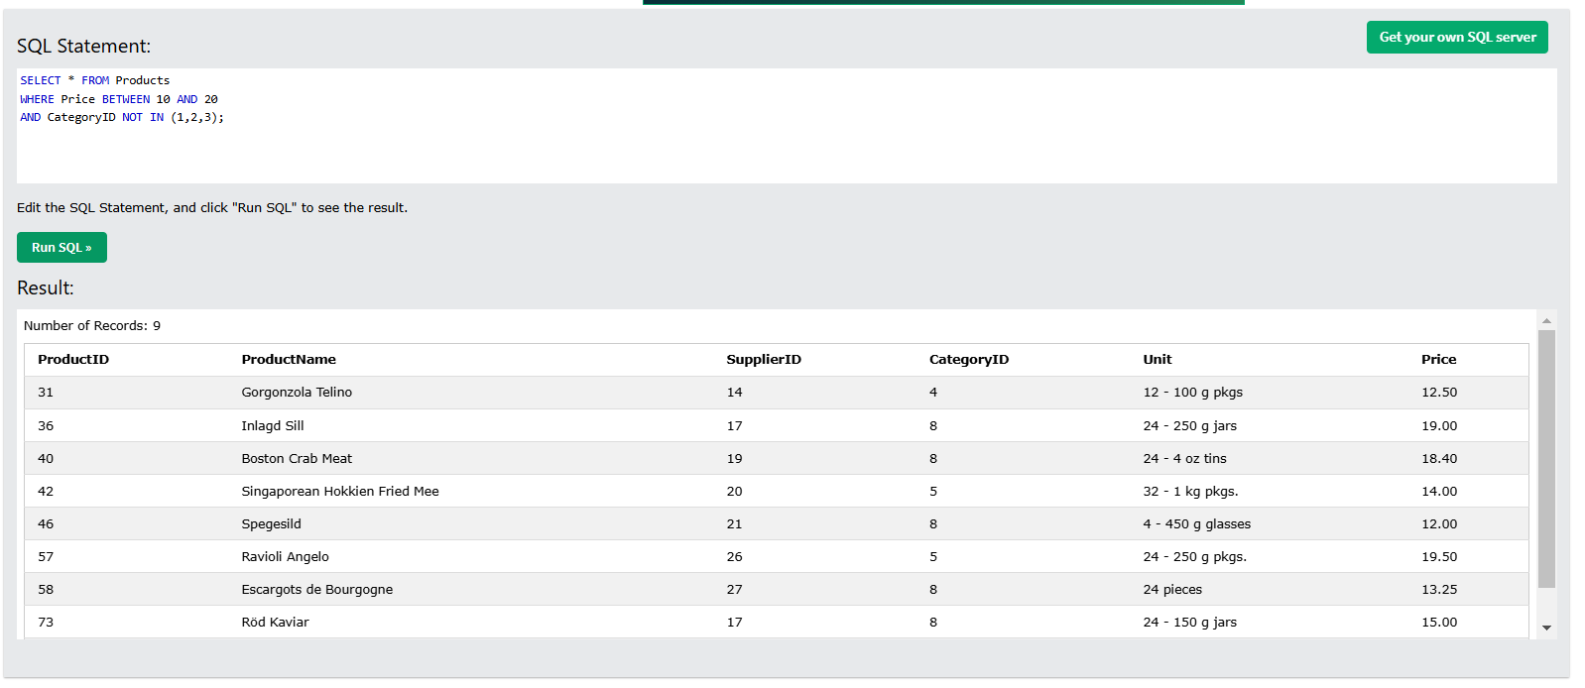
BETWEEN Text Values Example
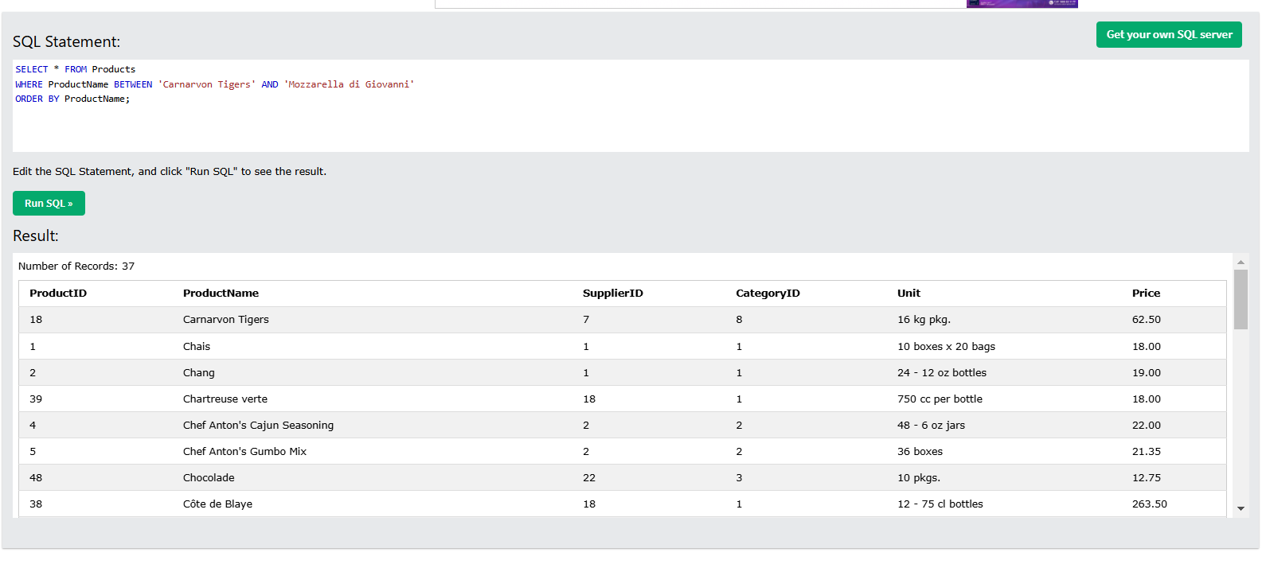
NOT BETWEEN Text Values Example
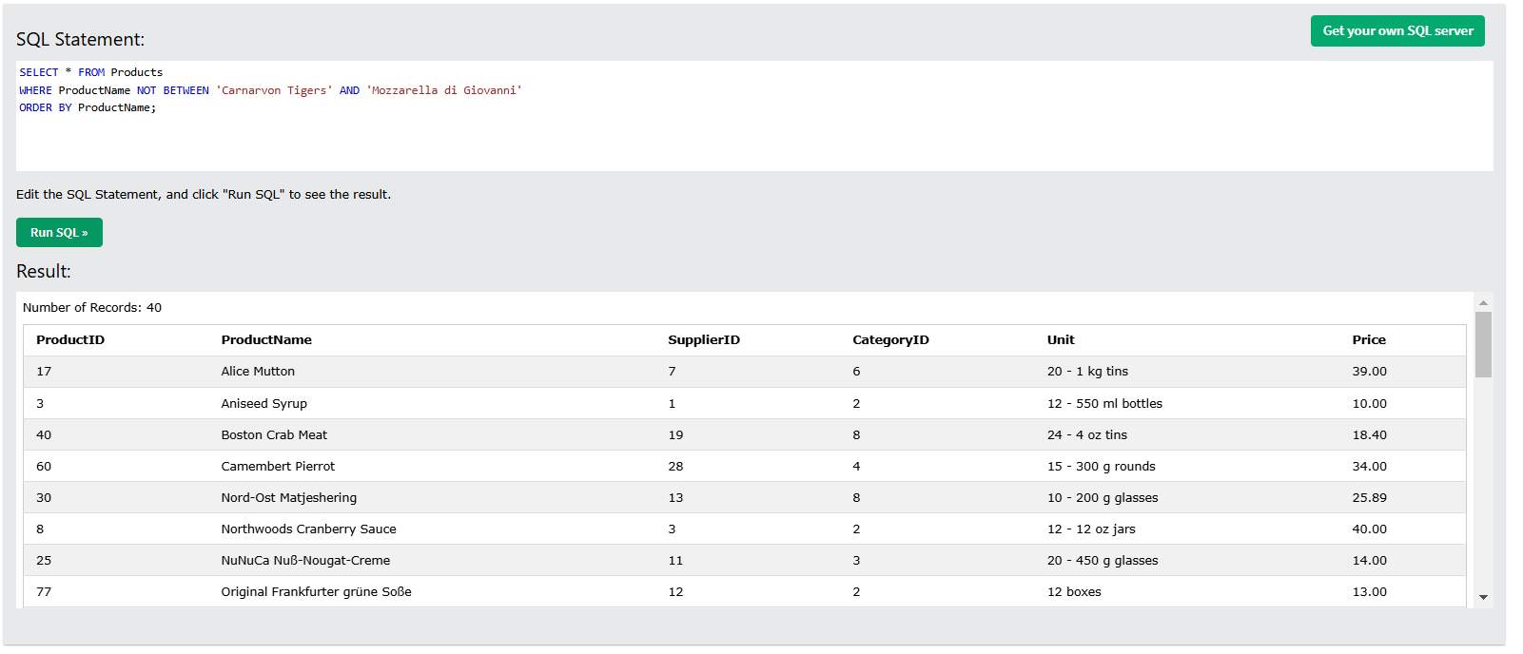
Alias for Columns Examples
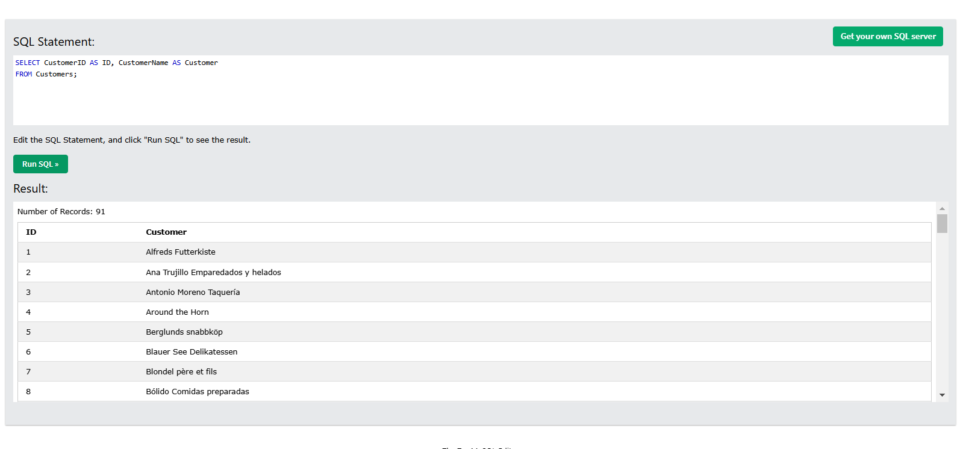
Alias for Tables Example
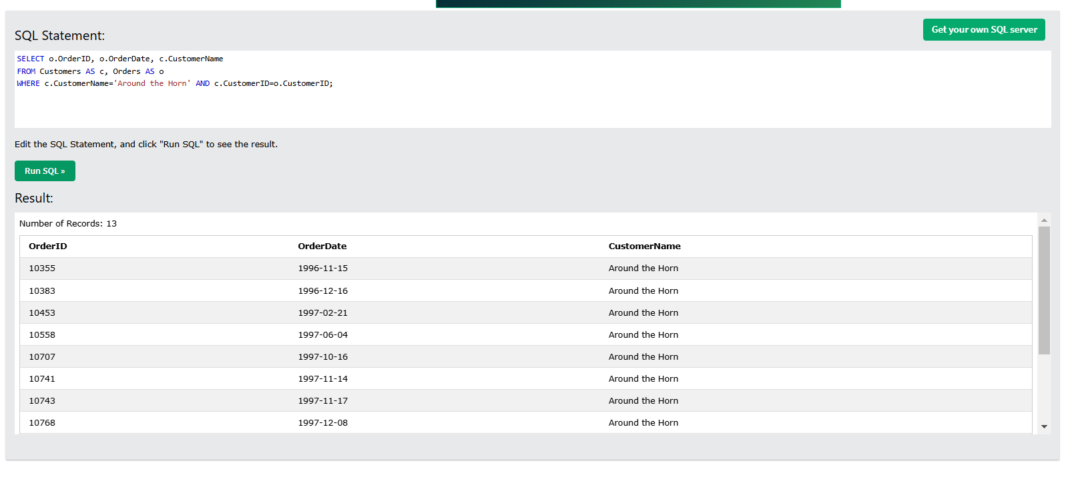
MySQL Joining Tables
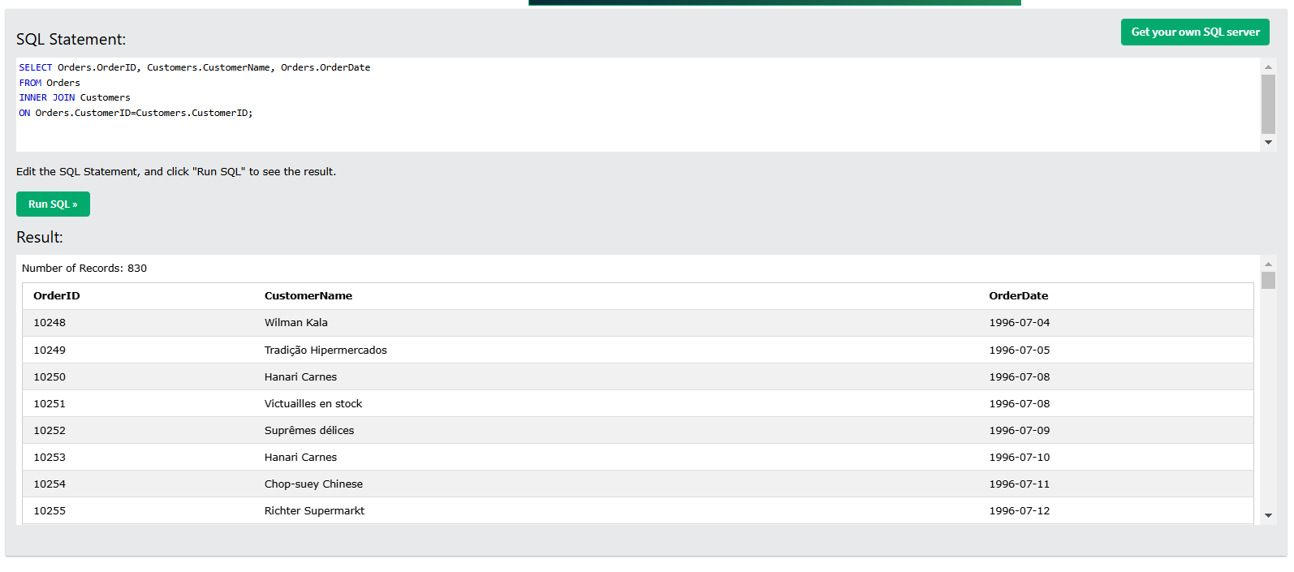
MySQL INNER JOIN Example
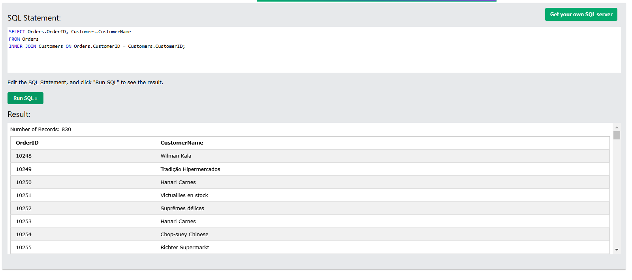
JOIN Three Tables
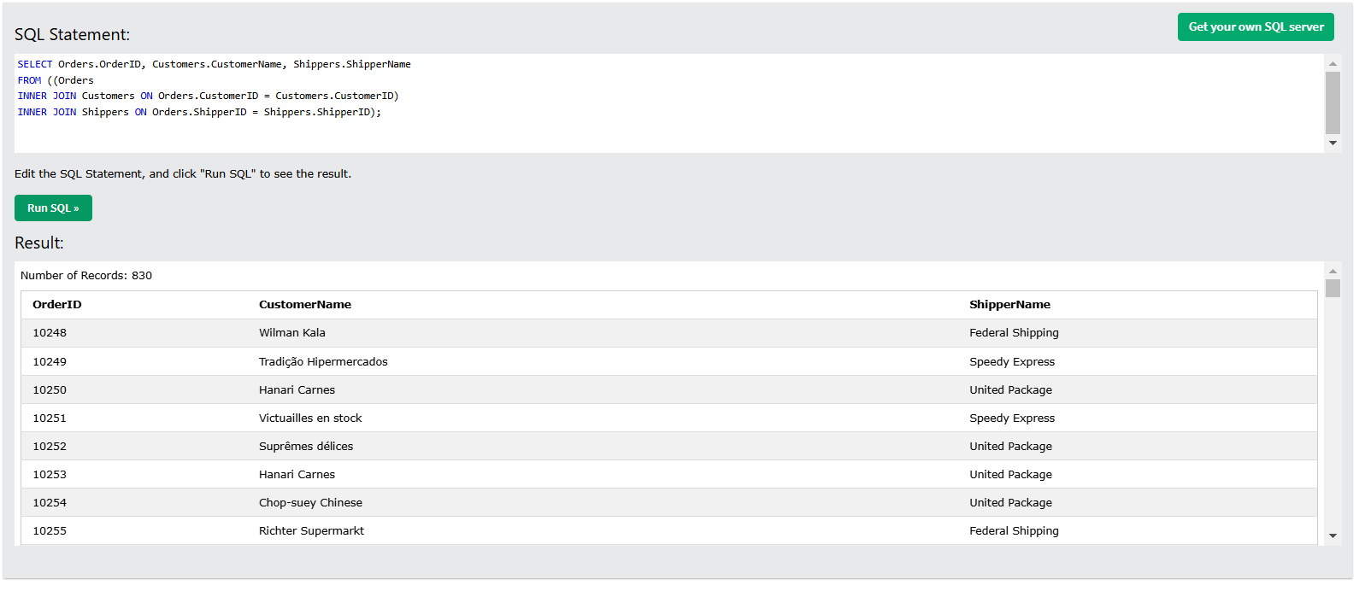
MySQL LEFT JOIN Example
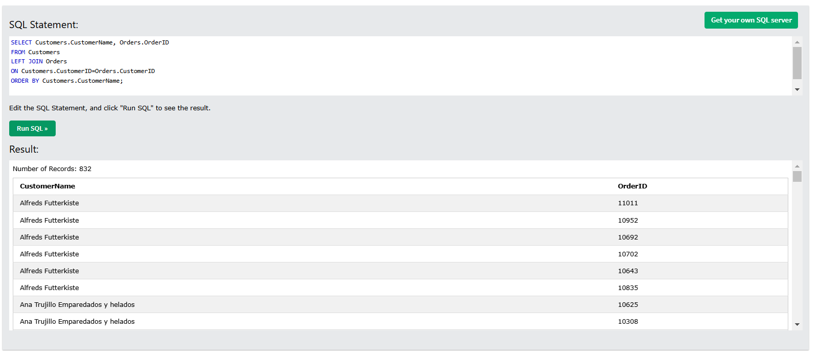
MySQL RIGHT JOIN Example
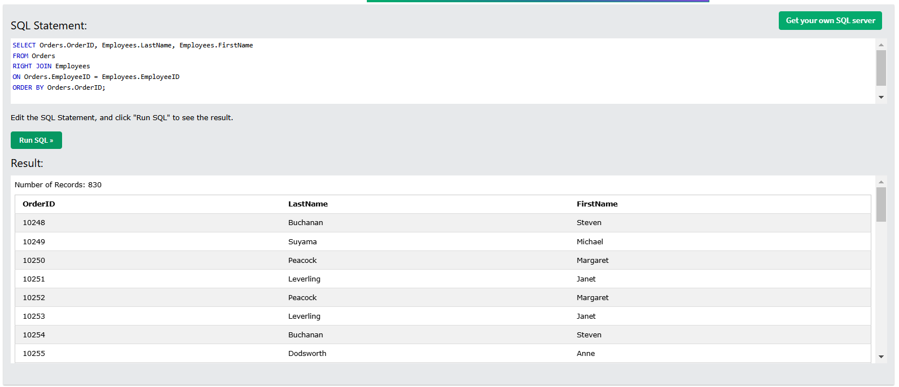
MySQL CROSS JOIN Example
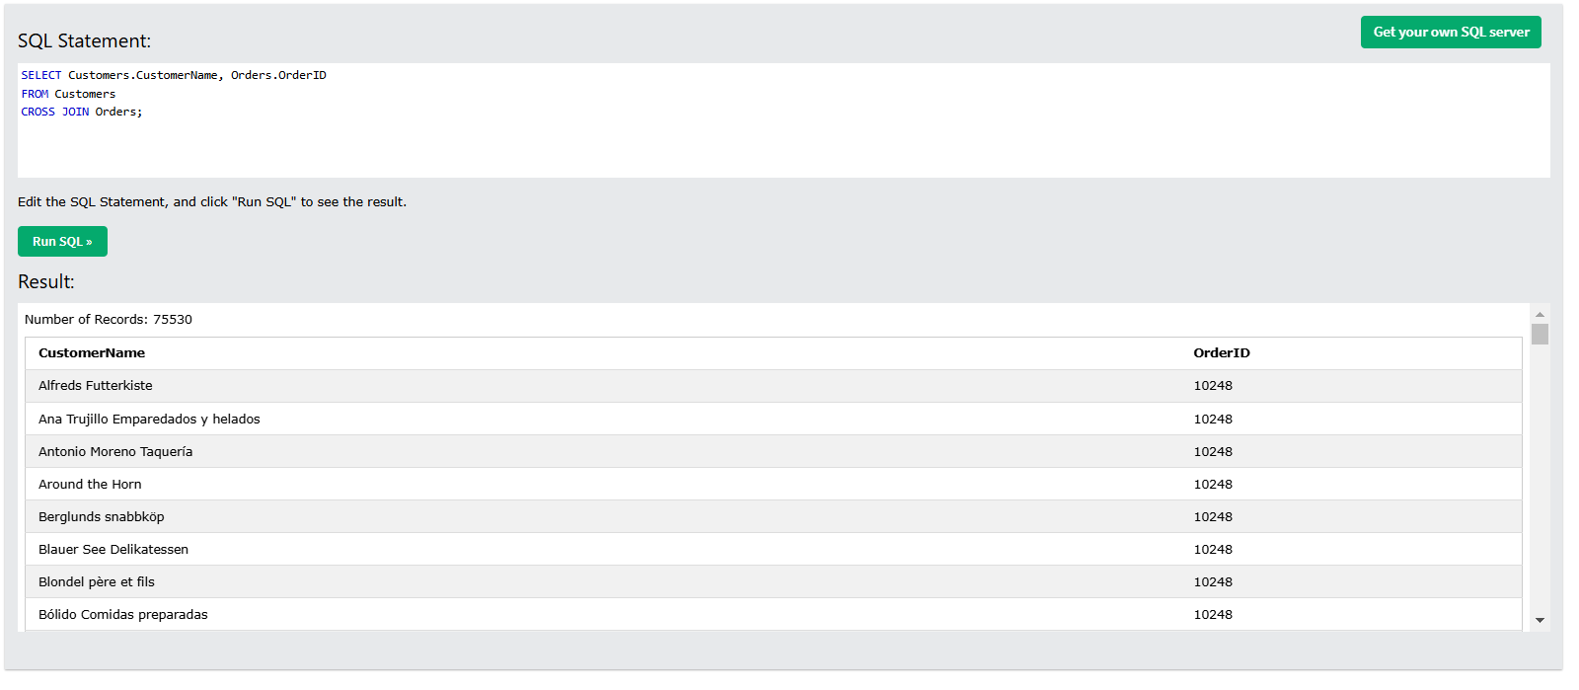
MySQL Self Join Example
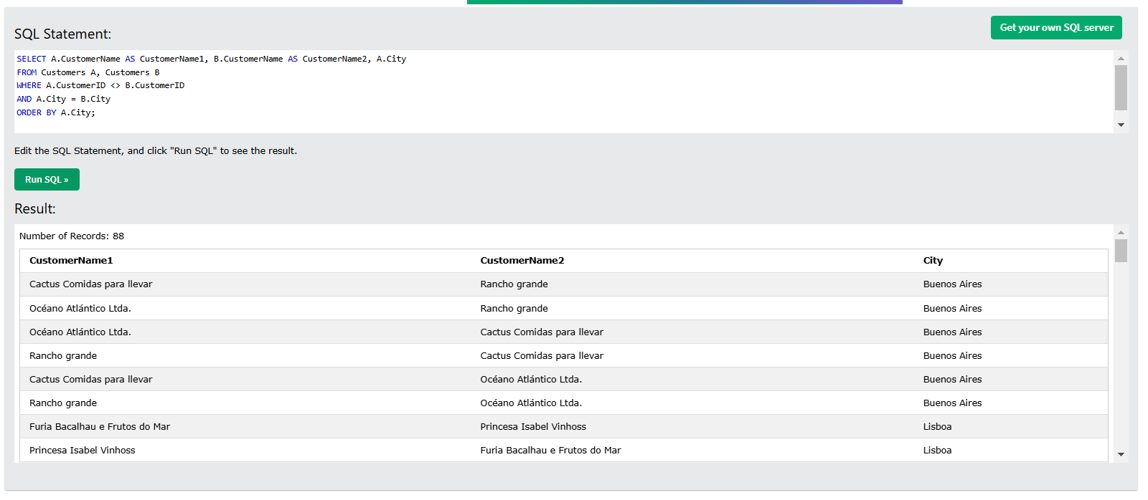

SQL UNION Example
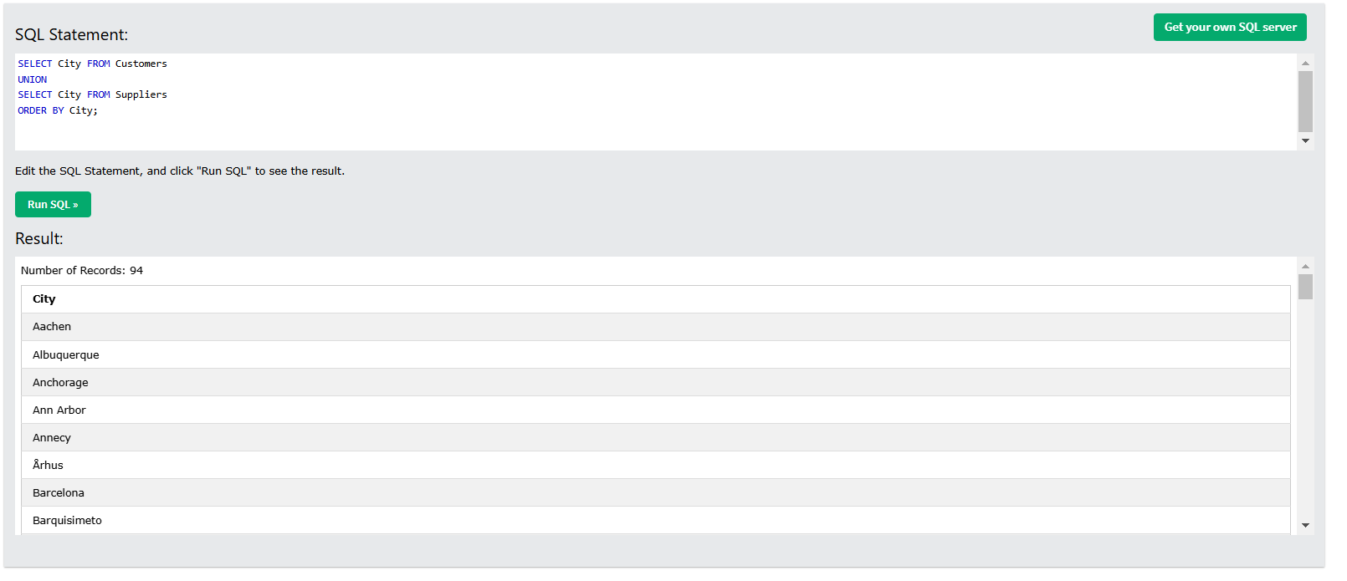
SQL UNION ALL Example
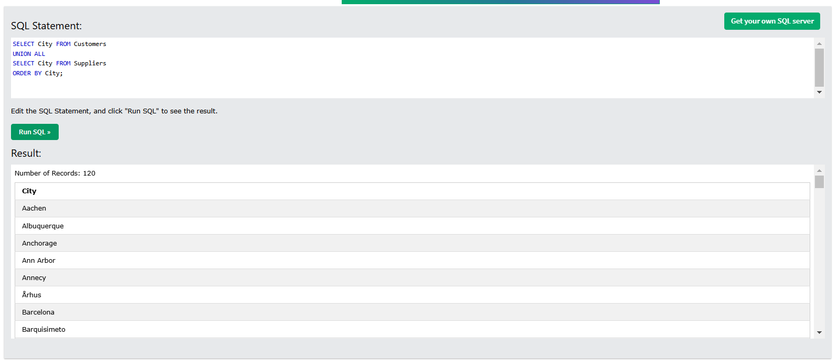
SQL UNION With WHERE
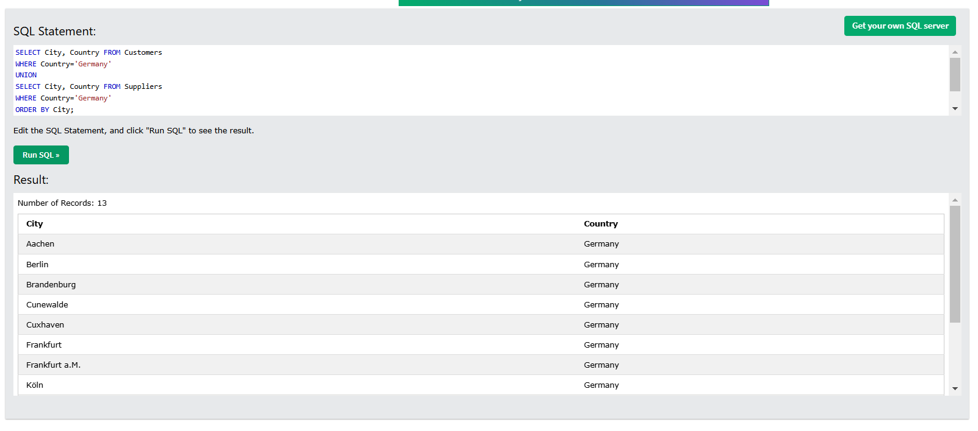

SQL UNION ALL With WHERE
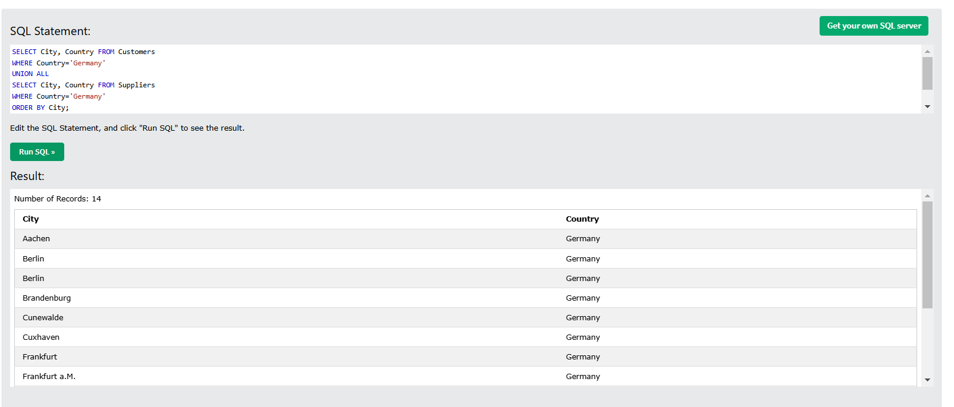
Another UNION Example
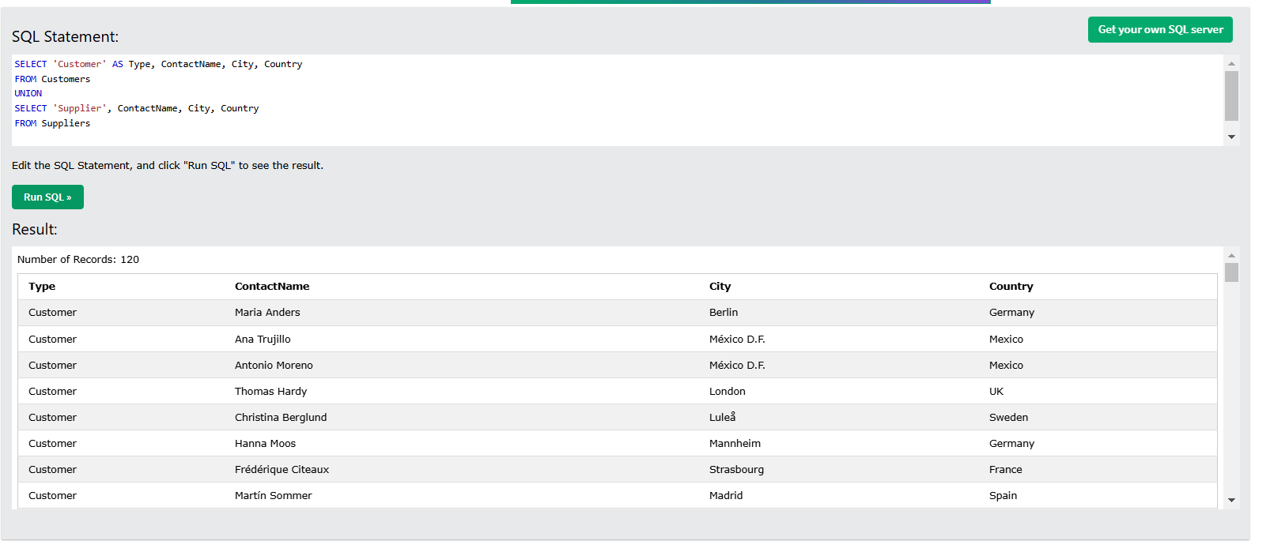
MySQL GROUP BY Examples
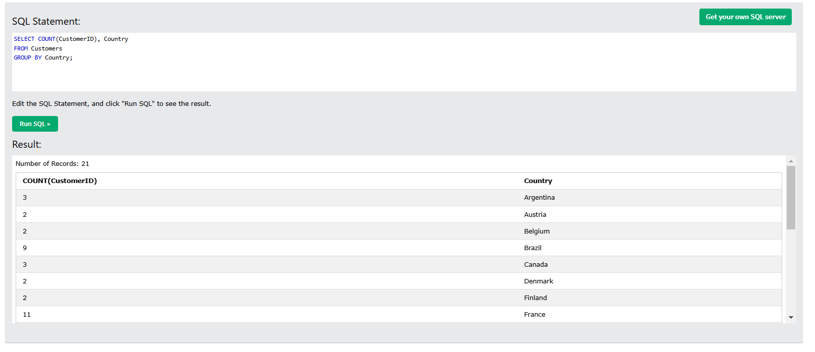

GROUP BY With JOIN Example
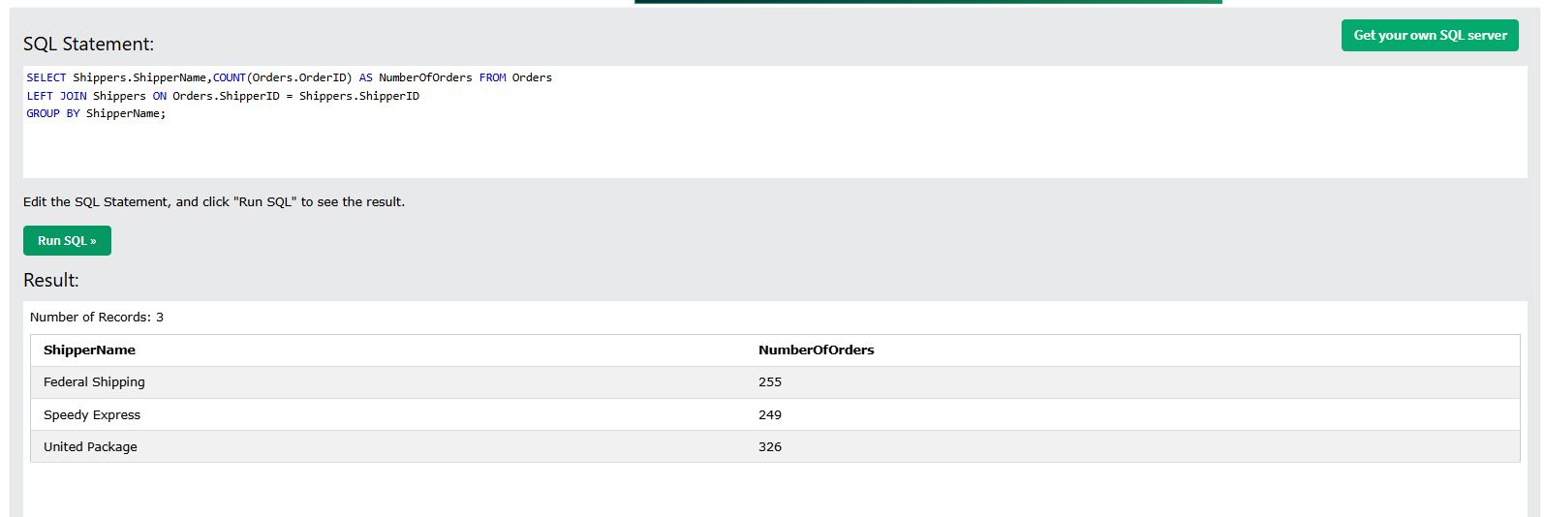
MySQL HAVING Examples
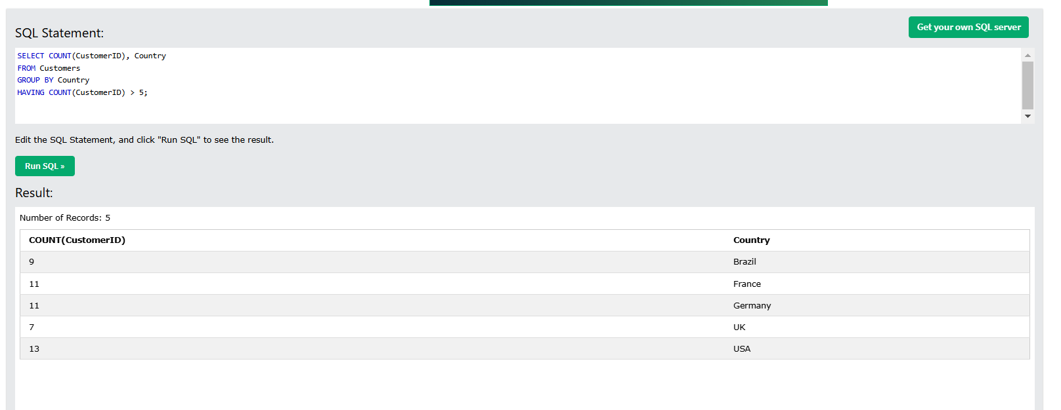
More HAVING Examples
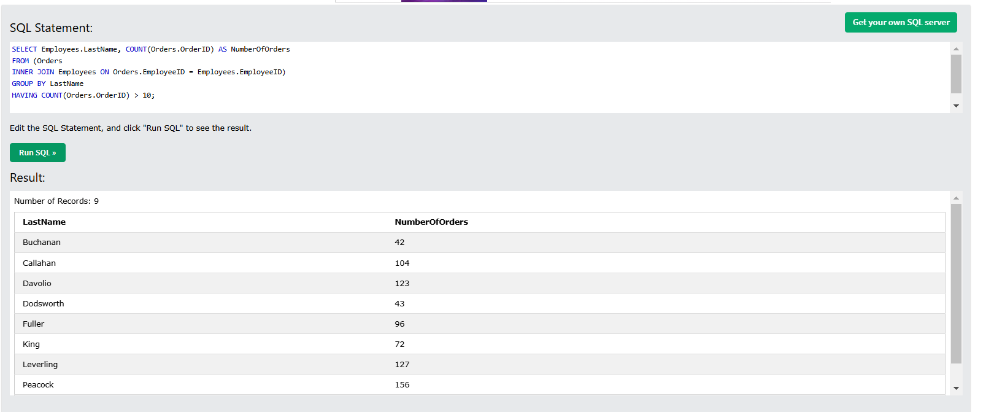

MySQL EXISTS Examples
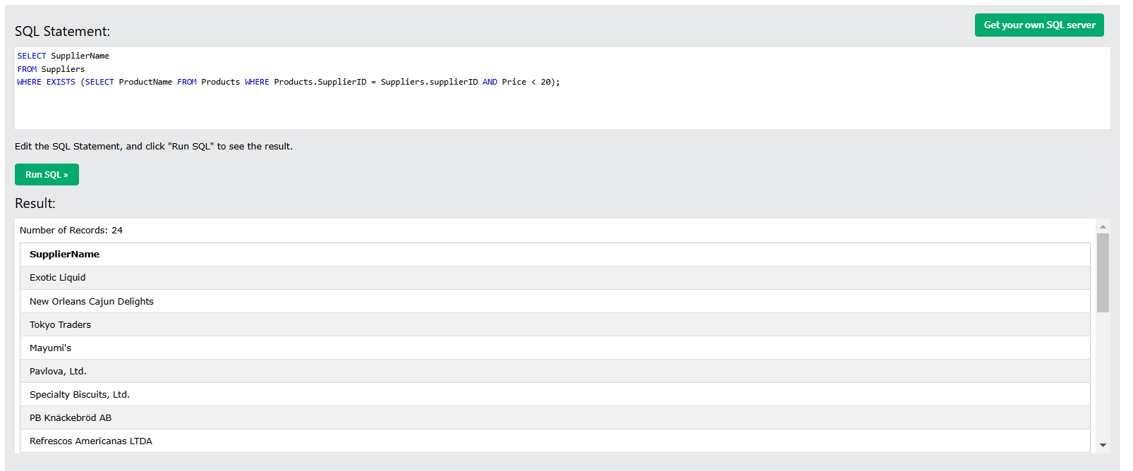
SQL ANY Examples
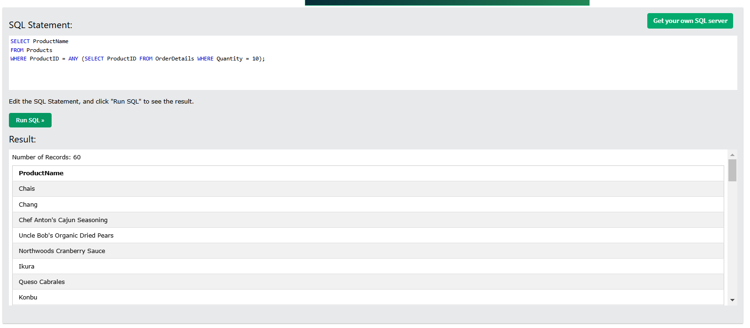
SQL ALL Examples
